**KL University**



**Department of Computer Science Engineering**

**Course code -15CS2007**

**Database Systems**

**II B.Tech – 2 ndSemester**

**Academic Year 2016-2017**

**Project Based Lab**

**ON**

**STUDENT ATTENDENCE MANAGEMENT SYSTEM**

**Submitted by**

**Section – S1**

**Batch No: 08**

|  |  |  |
| --- | --- | --- |
| Student ID | Student Name | Department |
| 150030338 | J.PRANAYREDDY | CSE |
| 150030590 | MOHAMMAD SAHIL AFRID FAROOKHI | CSE |

**K L University**

**DEPARTMENT OF COMPUTER SCIENCE ENGINEERING**

**(DST-FIST Sponsored Department)**



**CERTIFICATE**

This is to certify that the course based project entitled **“STUDENT ATTENDENCE MANAGEMENT SYSTEM”** is a bonafide work done by **J.PRANAY REDDY(150030338), MOHAMMAD SAHIL AFRID FAROOKHI(150030590),** in partial fulfilment of the requirement for the award of degree in **BACHELOR OF TECHNOLOGY** in **Computer Science Engineering** during the academic year **2016-2017.**

**Faculty In Charge Head of the Department**

**Mr. Hari Kiran Vege Prof. Srikanth Vemuru**

**DEPARTMENT OF COMPUTER SCIENCE ENGINEERING**

**(DST-FIST Sponsored Department)**



**DECLARATION**

We hereby declare that this project based lab report entitled **“STUDENT ATTENDENCE MANAGEMENT SYSTEM** has been prepared by us in partial fulfillment of the requirement for the award of degree “**BACHELOR OF TECHNOLOGY in COMPUTER SCIENCE ENGINEERING**” during the academic year 2016-2017.

We also declare that this project based lab report is of our own effort and it has not been submitted to any other university for the award of any degree.

**Date: 09-04-2017**

**Place: Vaddeswaram**

|  |  |
| --- | --- |
| **Name** | **Student ID** |
| **J.PRANAY REDDY** | **150030338** |
| **MOHAMMAD SAHIL AFRID FAROOKHI** | **150030590** |

# ACKNOWLEDGMENTS

My sincere thanks to V. Hari Kiran in the Lab for their outstanding support throughout the project for the successful completion of the work.

Finally, it is pleased to acknowledge the indebtedness to all those who deviated themselves directly or indirectly to make this project report success.

**PROJECT ASSOCIATES**

|  |  |
| --- | --- |
| **Name** | **Student ID** |
| **J.PRANAY REDDY** | **150030338** |
| **MOHAMMAD SAHIL AFRID FAROOKHI** | **150030590** |

Table of Contents

Abstract 6

Introduction 7

PROJECT DESCRIPTION 8

List of Entities & Attributes 9

ER Diagram (Conceptual Model) 11

Schema Diagram 12

Normalization & Final List of Relations 13

Create & Insert SQL Queries 15

SQL Queries related to Report Generation 27

Conclusion 40

# Abstract

Admin procure details of student and teacher from various different courses. The institution maintains the catalogue of student, teacher, course details in database. Computerization of attendance management system will reduce the manual work and avoid redundant data. Since the maintenance of attendance is done manual till date ,efficient report generation is failed. The attendance data are maintained in registers, it is difficult to maintain these registers for long time. Here the database is used to store the indent of required details by verifying the students and teachers information . In this, we deal with 3 modules. First module deals with Developing a DDL for creating the schema in the database, student details, teacher details ,course details, student attendance details ,report on attendance, section details etc. Second module deals with creating the tables to each individual tasks and inserting the accurate values into the tables etc. Third module deals with writing some queries with which one can get the required information about the query given and etc. So, finally we will create database for all those modules and integrate them to work properly…

# Introduction

  Database is an organized collection of data. The data is typically organized to model aspects of reality in a way that supports processes requiring information. A DBMS makes it possible for end users to create, read, update and delete data in a database. The DBMS essentially serves as an interface between the database and end users or application programs, ensuring that data is consistently organized and remains easily accessible. The DBMS manages three important things: the data, the database engine that allows data to be accessed, locked and modified and the database schema, which defines the database’s logical structure. These three foundational elements help provide concurrency, security, data integrity and uniform administration procedures. The DBMS can offer both logical and physical data independence. That means it can protect users and applications from needing to know where data is stored or having to be concerned about changes to the physical structure of data.

The main purpose of maintaining database for student attendance management is to reduce the manual work involved in allocating attendance to each student and make it convenient for the students and teachers to maintain the data about their students and also about the details available at them.Due to automation many loopholes that exist in the manual maintenance of the records can be removed. The speed of obtaining and processing the data will be fast. For future expansion the proposed system can be web enabled so that students can make various enquiries about academia. It takes a lot of time and causes many errors while data entering. Due to this, sometimes a more problems occur and they are teachers are facing many disputes with students. To solve the above problem, we design a data base which includes student details, attendance details, teacher details and course details. This program also helps us to know the attendance status on particular day of the student that is whether the he/she is present on that day or not.

# PROJECT DESCRIPTION

Computerization of attendance management system will reduce the manual work and avoid redundant data. Since the maintenance of attendance is done manual till date ,efficient report generation is failed. The attendance data are maintained in registers, it is difficult to maintain these registers for long time. Attendance Management System basically has Admin module. It has rights for creating any new entry of faculty and student details. User has rights of making daily attendance, generating report. Attendance report can be taken by given details of student details, date, and class. The system should be designed in such a way that only authorized people should be allowed to access some particular modules. The records should be modified by only administrators and no one else. The user should always be in control of the application and not the vice versa.

Student details consist of roll no and personal details for new batch. It consists of personal details of student and academic details of the students with photo identity. Staff details helps to allot the subject and the subject code to the particular staffs. Time table details: It will retrieve the subject information and assign time table to the staffs. It will help the admin, staff to make the entry of attendance based of the subject and period allotted to the respective staff. Attendance details need to be stored in the data base subject wise along with period and date of conduction of the class. It will help to the get report of weekly and consolidate of the attendance. Report details: Report can be taken by daily, weekly and consolidate: weekly report get all hour details of attendance starting date to ending date and display the status. Consolidate report get all student attendance details starting date to ending date status help for the eligibility criteria of the student to attend the examination. Attendance details: It assists the staff to mark attendance to the students for their subject. This will authenticate the staff before making the entry.

Attendance Management System is a software developed for daily student attendance in schools, collages and institutes**.** If facilitates to access the attendance information of a particular student in a particular class. The information **is** sorted by the operators, which will be provided by the teacher for a particular class. This system will also help in evaluating attendance eligibility criteria of a student.

**Purpose:-**

The purpose of developing attendance management system is to computerized the tradition way of taking attendance. Another purpose for developing this database system is to generate the report automatically at the end of the session or in the between of the session.

**Scope:-**

The scope of the project is the system on which the software is installed, i.e. the project is developed as a desktop application, and it will work for a particular institute. But later on the project can be modified to operate it online.

# List of Entities & Attributes

**ENTITY 1- STUDENT :**

1. **STUDENT ID**
2. **STUDENT NAME**
3. **STUDENT MAIL**
4. **YEAR**
5. **SECTION NUMBER**

**ENTITY 2- ATTENDENCE:**

1. **ATTENDENCE ID**
2. **2.STUDENT ID**
3. **SESSION NUMBER**
4. **SEMESTER NUMBER**
5. **STATUS**
6. **SECTION NUMBER**
7. **COURSE CODE**
8. **DATE OF ATTENDENCE**

**ENTITY 3- COURSE**

1. **COURSE ID**
2. **COURSE NAME**
3. **LTP STRUCTURE**
4. **TEACHER ID**

**ENTITY 4-ROOM**

1. **ROOM NUMBER**
2. **FLOOR NUMBER**
3. **BLOCK NAME**

**ENTITY 5- SECTION**

1. **SECTION NUMBER**
2. **SECTION SLOT NO**
3. **ROOM NO**

**ENTITY 6- TEACHER**

1. **TEACHER ID**
2. **TEACHER NAME**
3. **TEACHER EMAIL**
4. **SECTION NUMBER**

# ER Diagram (Conceptual Model)

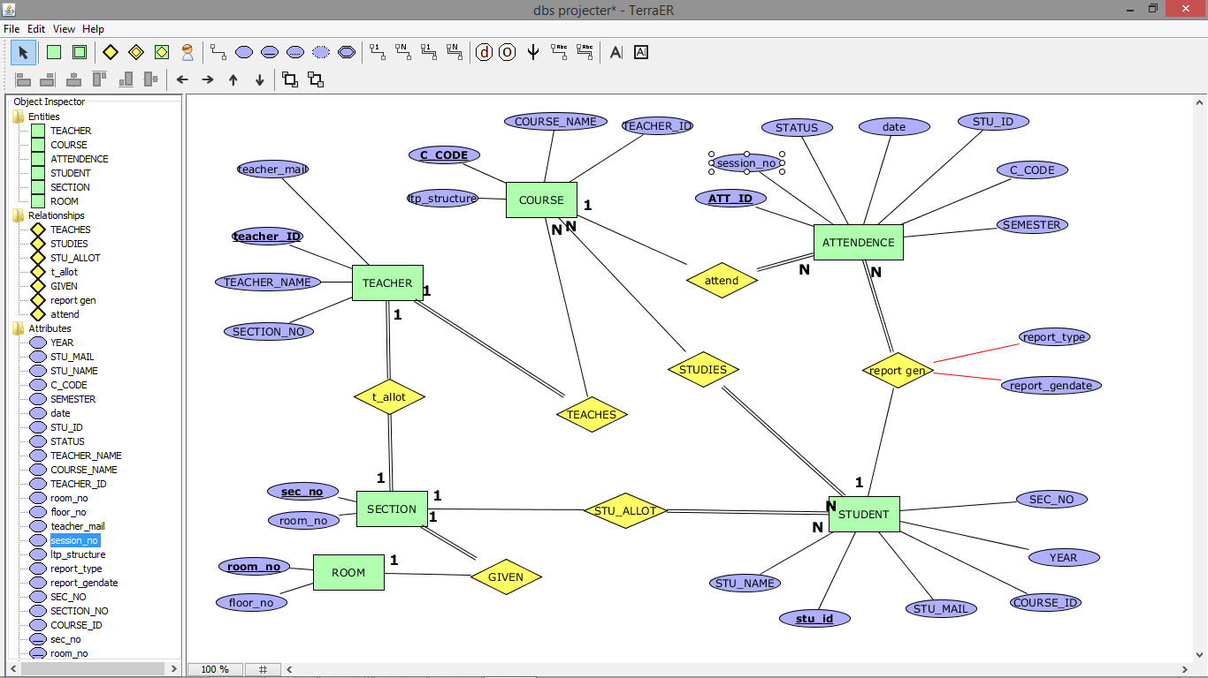

**ER DIAGRAM FOR STUDENT ATTENDENCE MANAGEMENT SYSTEM**

# Schema Diagram

|  |  |  |  |
| --- | --- | --- | --- |
| TEACHER ID | TEACHER NAME | TEACHER EMAIL | SECTION_NO |

|  |  |  |  |
| --- | --- | --- | --- |
| COURSE_ID | COURSE NAME | LTP STRUCTURE | TEACHER ID |

|  |  |  |  |
| --- | --- | --- | --- |
| COURSE_ID | COURSE NAME | LTP STRUCTURE | TEACHER ID |

|  |  |  |  |  |  |  |  |
| --- | --- | --- | --- | --- | --- | --- | --- |
| ATTENDENCE_ID | SEMESTER | SESSION NO | SECTION NO | STATUS | DATE | STUDENT ID | COURSE CODE |

|  |  |  |  |  |  |
| --- | --- | --- | --- | --- | --- |
| STUDENT ID | STUDENT NAME | STUDENT MAIL | SECTION NO | COURSE ID | YEAR OF STUDY |

|  |  |  |  |
| --- | --- | --- | --- |
| COURSE_ID | COURSE NAME | LTP STRUCTURE | TEACHER ID |

|  |  |  |  |
| --- | --- | --- | --- |
| TEACHER ID | TEACHER NAME | TEACHER EMAIL | SECTION_NO |

|  |  |  |
| --- | --- | --- |
| SECTION NUMBER | SECTION SLOT | ROOM NUMBER |

|  |  |  |
| --- | --- | --- |
| ROOM NUMBER | FLOOR NUMBER | BLOCK NAME |

# Normalization & Final List of Relations

**UNF**(COURSE_ID,COURSE_NAME,LTP_STRUCTURE,TEACHER_ID,TEACHER_NAME,SECTION_NO,TEACHER_MAIL,SECTION_NO,SECTION_SLOT_NO,ROOM_NO,FLOOR_NO,BLOCK_NAME,STUDENT_NAME,STUDENT_ID,STUDENT_MAIL,YEAROF_JOIN,ATTENDENCE_ID,SESSION_NO,SEMESTER_NO,STATUS,DATE_OF_ATTENDENCE)

**1NF:**

COURSE_ID -> COURSE_ID,COURSE_NAME,LTP_STRUCTURE,TEACHER_ID,TEACHER_NAME,TEACHER_MAIL

TEACHER_ID -> TEACHER_NAME,TEACHER_MAIL

SECTION_NO -> SECTION_SLOT_NO,ROOM_NO

ROOM_NO ->FLOOR_NO,BLOCK_NAME

STUDENT_ID ->STU_NAME,STU_MAIL,YEAROF_JOIN

ATTENDENCE_ID -> STU_ID,SECTION_NO,SEMESTER,SESSION_NO

STU_ID,ATTENDENCE_ID -> STATUS,DATE_OF_ATTENDENCE

FFD (STUDENT_ID ,ATTENENCE_ID,COURSE_ID,SECTION_NO,ROOM_NO, TEACHER_ID)

**2NF:**

STUDENT( student_id,student_name,student_mail,yearoff_join)

course(course_id,course_name,ltp_structure,teacher_id,teacher_name,teacher_mail)

section(section_no,section_slot_no,room_no,floor_ no,block_name)

attendence(attendence_id,student_id,section_no,semester,session_no)

att_status(attendence_id,stu_id,status,date_of_attendence)

**3nf:**

STUDENT( student_id,student_name,student_mail,yearoff_join)

course(course_id,course_name,ltp_structure,teacher_id(fk));

section(section_no,section_slot_no,room_no(fk));

attendence(attendence_id,student_id(fk),section_no(fk),semester,session_no)

att_status(attendence_id(fk),stu_id(fk),status,date_of_attendence);

teacher(teacher_id,teacher_name,teacher_mail,section_no

(fk));

room(room_id, floor_ no,block_name);

**C**

# **Create & Insert** SQL **Queries**

**1.COURSE TABLE:**

**____________________________________**

**CREATE TABLE IF NOT EXISTS COURSE**

**(**

**COURSE_ID INT NOT NULL,**

**COURSE_NAME VARCHAR(50) NOT NULL,**

**TEACHER_ID INT NOT NULL,**

**LTP_STRUCTURE INT ,**

**PRIMARY KEY(COURSE_ID),**

**CONSTRAINT FK_1 FOREIGN KEY(TEACHER_ID) REFERENCES TEACHER(TEACHER_ID)**

**);**

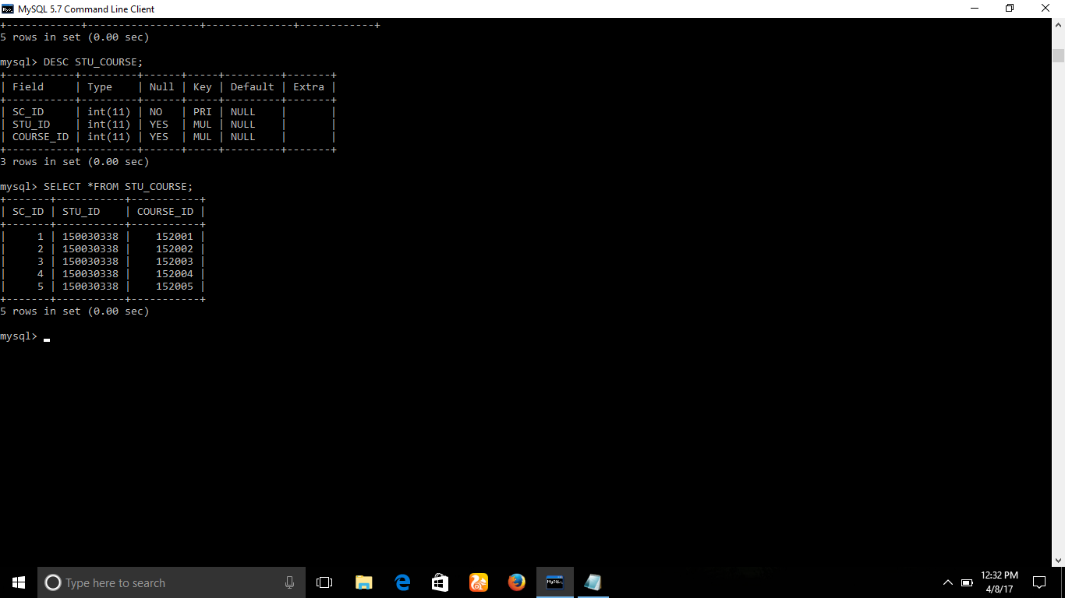

**2.TEACHER TABLE:**

**___________________________________**

**CREATE TABLE IF NOT EXISTS TEACHER**

**(**

**TEACHER_ID INT NOT NULL,**

**TEACHER_NAME VARCHAR(50),**

**TEACHER_MAIL VARCHAR(50),**

**SECTION_NO INT,**

**PRIMARY KEY(TEACHER_ID),**

**CONSTRAINT FK_7 FOREIGN KEY(SECTION_NO) REFERENCES SECTION(SEC_NO),**

**);**

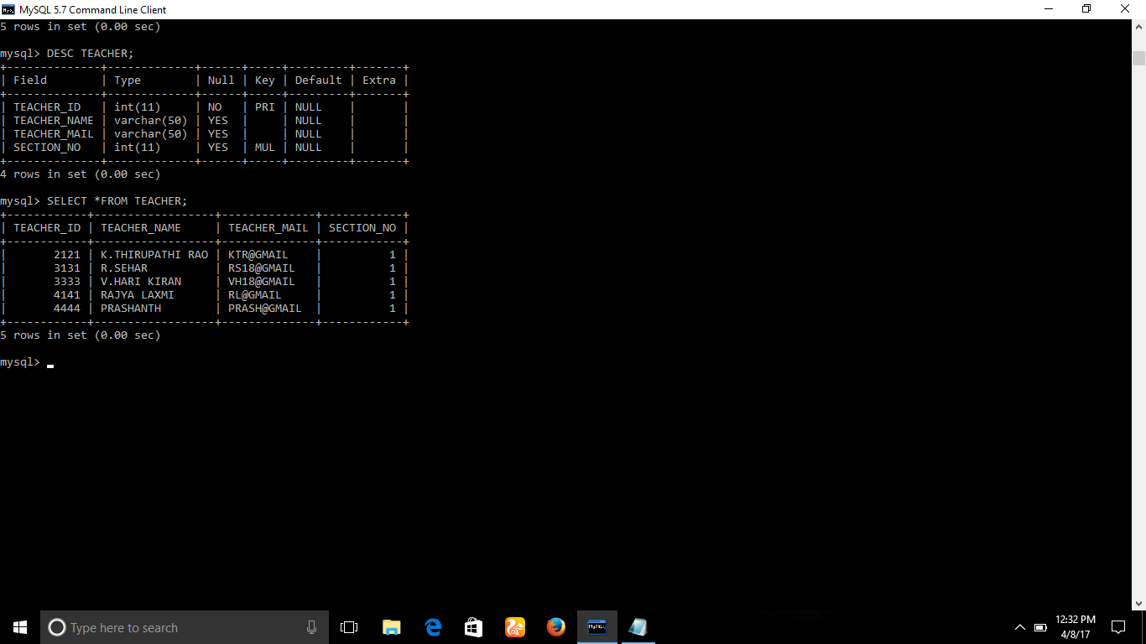

**3.ATTENDENCE TABLE:**

**____________________________________**

**CREATE TABLE IF NOT EXISTS ATTENDENCE**

**(**

**ATTENDENCE_ID INT,**

**STU_ID INT ,**

**SEMESTER INT,**

**SESSION_NO INT,**

**SECTION_NO INT,**

**STATUS VARCHAR(50),**

**C_CODE INT,**

**DATE VARCHAR(50),**

**PRIMARY KEY(ATTENDENCE_ID),**

**CONSTRAINT FK_2 FOREIGN KEY(STU_ID) REFERENCE STUDENT(STU_ID),**

**CONSTRAINT FK_3 FOREIGN KEY(SECTION_NO) REFERENCES SECTION(SEC_NO),**

**CONSTRAINT FK_4 FOREIGN KEY(C_CODE) REFERENCES COURSE(COURSE_ID));**

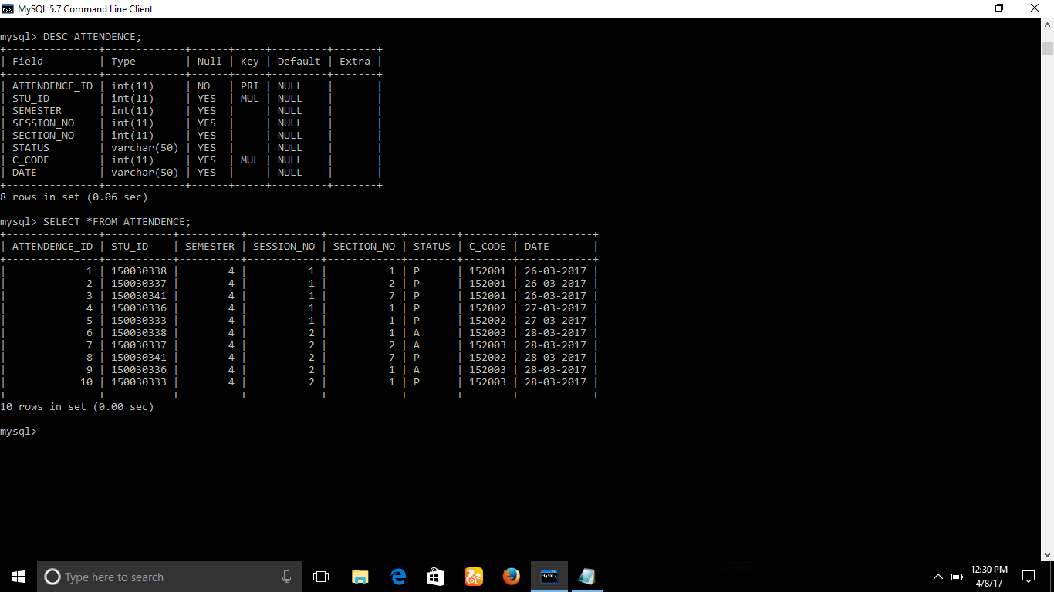

**4.STUDENT TABLE:**

**________________________________________**

**CREATE TABLE IF NOT EXISTS STUDENT**

**(**

**STU_ID INT,**

**STU_NAME VARCHAR(50) NOT NULL,**

**STU_MAIL VARCHAR(50) NOT NULL,**

**YEAR INT,**

**SEC_NO INT,**

**COURSE_ID INT**

**PRIMARY KEY(STU_ID),**

**CONSTRAINT FK_5 FOREIGN KEY(SEC_NO) REFERENCE SECTION(SEC_NO),**

**);**

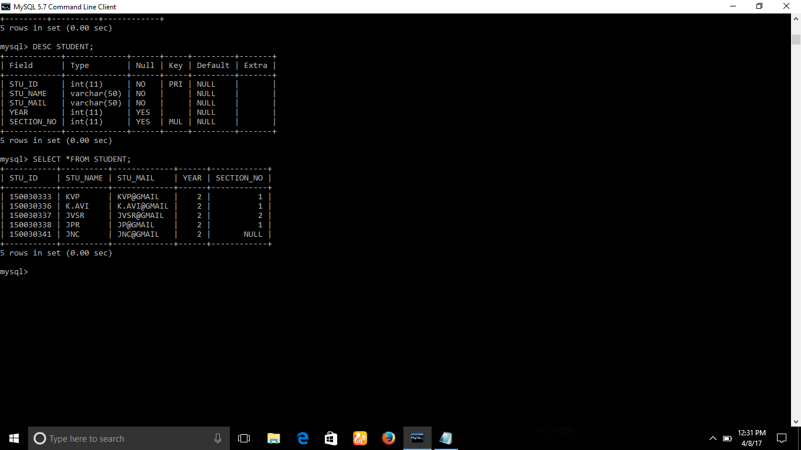

**5.SECTION TABLE:**

**__________________________________________**

**CREATE TABLE IF NOT EXISTS SECTION**

**(**

**SEC_NO INT,**

**SEC_SLOT_NO,**

**ROOM_NO INT,**

**PRIMARY KEY(SEC_NO),**

**CONSTRAINT FK_6 FOREIGN KEY(ROOM_NO) REFERENCES ROOM(ROOM_NO)**

**);**

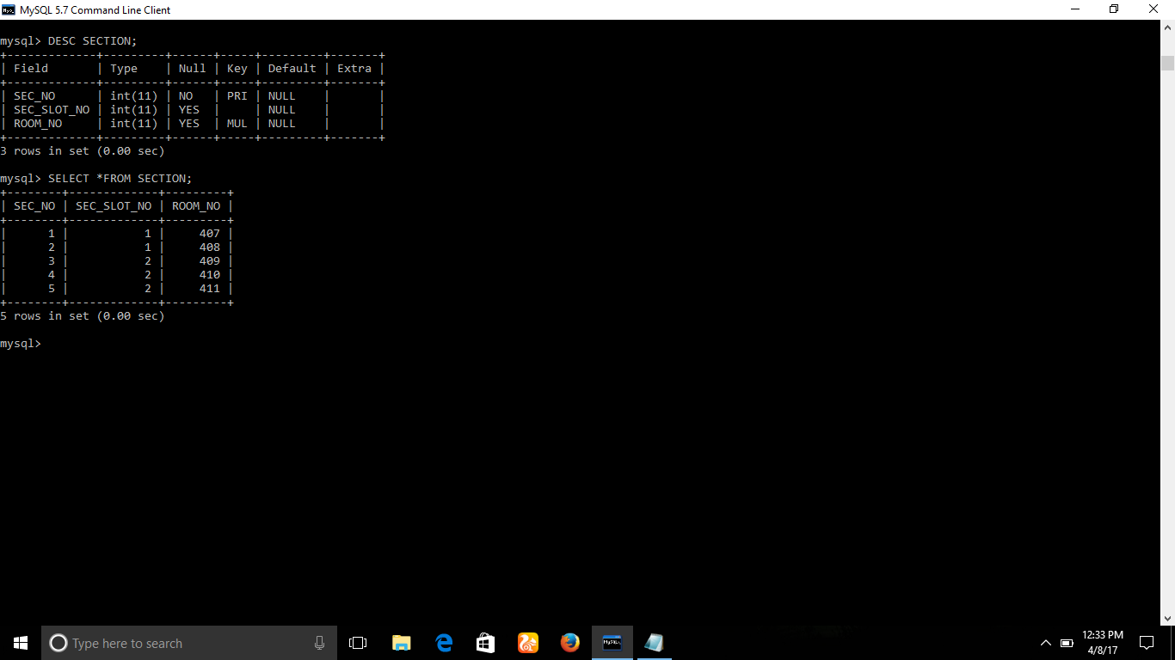

**6.ROOM TABLE:**

**__________________________________________**

**CREATE TABLE IF NOT EXISTS ROOM**

**(**

**ROOM_NO INT,**

**FLOOR_NO INT,**

**BLOCK_NAME VARCHAR(50),**

**PRIMARY KEY(ROOM_NO),**

**);**

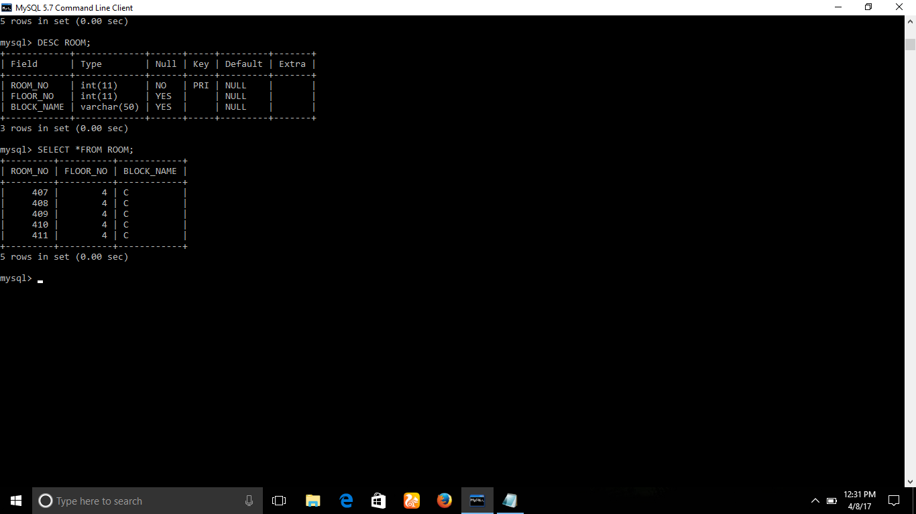

**7.STUDENT_COARSE TABLE:**

**__________________________________________**

**CREATE TABLE IF NOT EXISTS STU_COURSE**

**(**

**SC_ID INT,**

**STU_ID INT,**

**COURSE_ID INT,**

**PRIMARY KEY(SC_ID),**

**CONSTRAINT FK_18 FOREIGN KEY(STU_ID) REFERENCES STUDENT(STU_ID),**

**CONSTRAINT FK_19 FOREIGN KEY(COURSE_ID) REFERENCES COURSE(C_CODE),**

**);**



**INSERTIONS INTO THE TABLES:**

**___________________________________________**

**COURSE TABLE INSERTION:**

**___________________________________________**

**INSERT INTO COURSE VALUES ( 152001,'DBMS',3333,222);**

**INSERT INTO COURSE VALUES ( 152002,'CN',4444,202);**

**INSERT INTO COURSE VALUES ( 152003,'SA',3131,200);**

**INSERT INTO COURSE VALUES ( 152004,'OS',2121,202);**

**INSERT INTO COURSE VALUES ( 152005,'PS',4141,200);**

**____________________________________________**

**STUDENT TABLE INSERTION:**

**____________________________________________**

**INSERT INTO STUDENT VALUES( 150030338,'JPR','JP@GMAIL',2,1);**

**INSERT INTO STUDENT VALUES( 150030337,'JVSR','JVSR@GMAIL',2,2);**

**INSERT INTO STUDENT VALUES( 150030341,'JNC','JNC@GMAIL',2,7);**

**INSERT INTO STUDENT VALUES(150030333,'KVP','KVP@GMAIL',2,1);**

**INSERT INTO STUDENT VALUES(150030336,'K.AVI','K.AVI@GMAIL',2,1);**

**____________________________________________**

**SECTION TABLE:**

**____________________________________________**

**INSERT INTO SECTION VALUES(1,1,407);**

**INSERT INTO SECTION VALUES(2,1,408);**

**INSERT INTO SECTION VALUES(3,2,409);**

**INSERT INTO SECTION VALUES(4,2,410);**

**INSERT INTO SECTION VALUES(5,2,411);**

**_____________________________________________**

**ROOM TABLE:**

**______________________________________________**

**INSERT INTO ROOM VALUES(407,4,'C');**

**INSERT INTO ROOM VALUES(408,4,'C');**

**INSERT INTO ROOM VALUES(409,4,'C');**

**INSERT INTO ROOM VALUES(410,4,'C');**

**INSERT INTO ROOM VALUES(411,4,'C');**

**____________________________________________**

**TEACHER TABLE:**

**____________________________________________**

**INSERT INTO TEACHER VALUES(3333,'V.HARI KIRAN','VH18@GMAIL',1);**

**INSERT INTO TEACHER VALUES(4444,'PRASHANTH','PRASH@GMAIL',1);**

**INSERT INTO TEACHER VALUES(3131,'R.SEHAR','RS18@GMAIL',1);**

**INSERT INTO TEACHER VALUES(2121,'K.THIRUPATHI RAO','KTR@GMAIL',1);**

**INSERT INTO TEACHER VALUES(4141,'RAJYA LAXMI','RL@GMAIL',1);**

**____________________________________________**

**ATTENDENCE TABLE:**

**_____________________________________________**

**INSERT INTO ATTENDENCE VALUES(1,150030338,4,1,1,'P',152001,'26-03-2017');**

**INSERT INTO ATTENDENCE VALUES(2,150030337,4,1,2,'P',152001,'26-03-2017');**

**INSERT INTO ATTENDENCE VALUES(3,150030341,4,1,7,'P',152001,'26-03-2017');**

**INSERT INTO ATTENDENCE VALUES(4,150030336,4,1,1,'P',152002,'27-03-2017');**

**INSERT INTO ATTENDENCE VALUES(5,150030333,4,1,1,'P',152002,'27-03-2017');**

**_____________________________________________**

**STU_COU TABLE:**

**_____________________________________________**

**INSERT INTO STU_COURSE VALUES(1,150030338,152001);**

**INSERT INTO STU_COURSE VALUES(2,150030338,152002);**

**INSERT INTO STU_COURSE VALUES(3,150030338,152003);**

**INSERT INTO STU_COURSE VALUES(4,150030338,152004);**

**INSERT INTO STU_COURSE VALUES(5,150030338,152005);**

# SQL Queries related to Report Generation

**QUERIES RELATED TO PROJECT:**

**______________________________________________**

**1.DISPLAY THE STUDENT INFORMATION BEING TAUGHT BY 'V.HARI KIRAN'?**

**ANS:**

**mysql> SELECT S.STU_ID,S.STU_NAME**

**-> FROM STUDENT S, SECTION SC, TEACHER T**

**-> WHERE S.SEC_NO =SC.SEC_NO AND T.SECTION_NO=SC.SEC_NO AND T.TEACHER_NAME='V.HARI KIRAN';**

**+-----------+----------V +**

**| STU_ID | STU_NAME |**

**+-----------+---------- +**

**| 150030333 | KVP |**

**| 150030336 | K.AVI |**

**| 150030338 | JPR |**

**+-----------+---------- +**

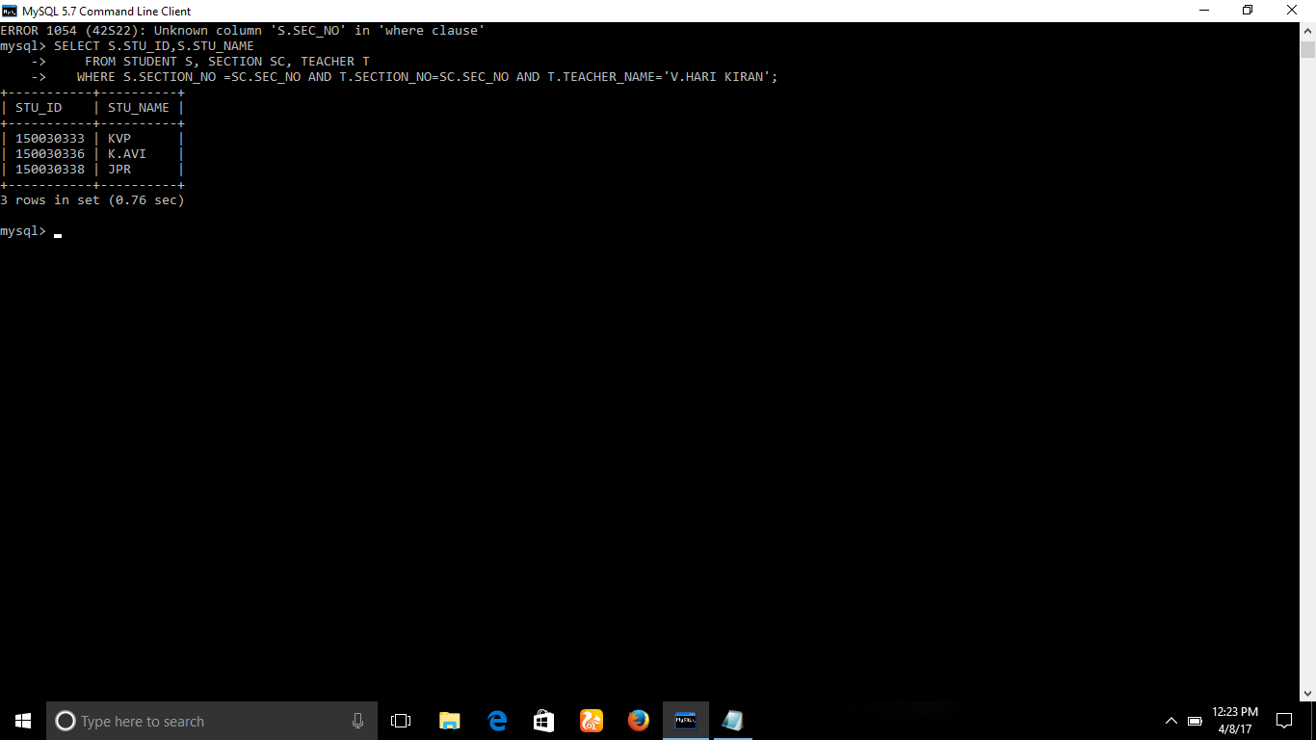

**2.HOW MANY STUDENTS ARE PRESENT ON THE DATE OF '27-03-2017'?**

**ANS:**

**mysql> SELECT COUNT(S.STU_ID)**

**-> FROM ATTENDENCE S**

**-> WHERE S.STATUS='P' AND S.DATE='27-03-2017';**

**+-----------------+**

**| COUNT(S.STU_ID) |**

**+-----------------+**

**| 2 |**

**+-----------------+**

**1 row in set (0.33 sec)**

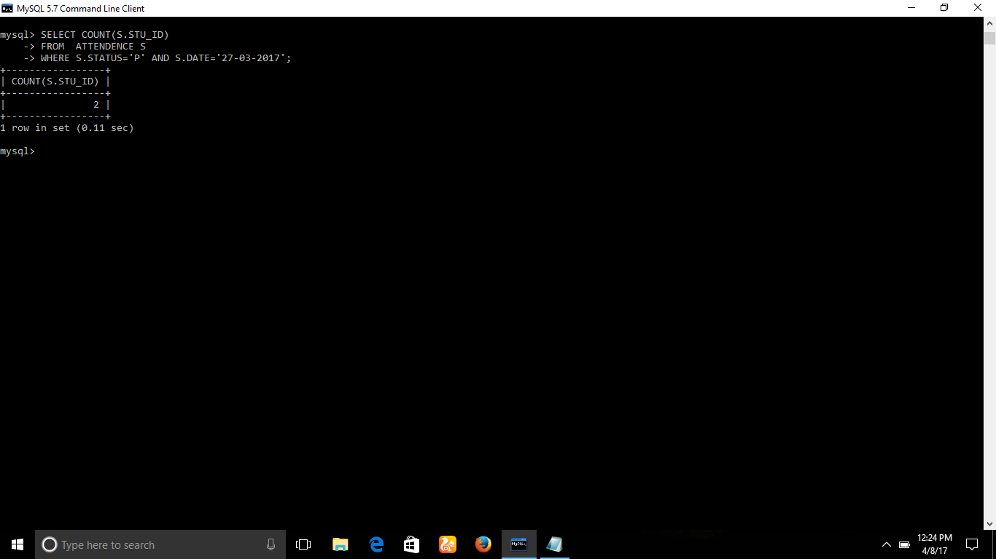

**3.DISPLAY THE STUDENT ATTENDENCE STATUS OF ID 150030338 ON '26-03-2017'?**

**ANS:**

**mysql> SELECT A.STATUS**

**-> FROM ATTENDENCE A**

**-> WHERE A.STU_ID=150030338 AND A.DATE='26-03-2017';**

**+--------+**

**| STATUS |**

**+--------+**

**| P |**

**+--------+**

**1 row in set (0.00 sec)**

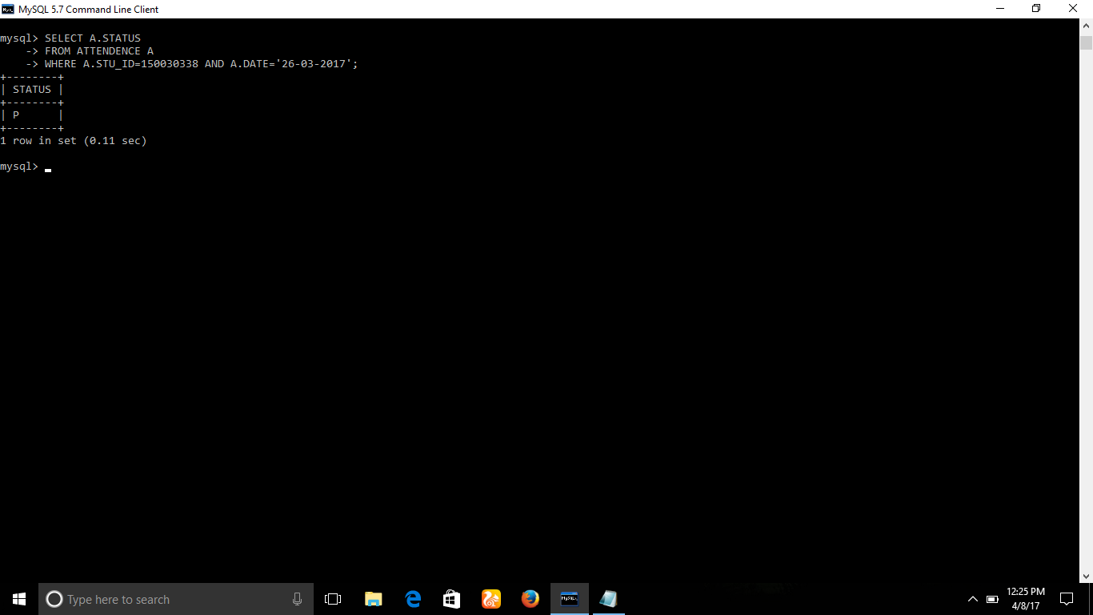

**4.HOW MANY STUDENTS ARE BEING INVOLVED IN COURSE 152001?**

**ANS:**

**mysql> SELECT COUNT(Sc.STU_ID)**

**-> FROM STUDENT S,COURSE C,STU_COURSE SC**

**-> WHERE S.STU_ID=SC.STU_ID AND C.COURSE_ID=SC.COURSE_ID AND SC.COURSE_ID=152001;**

**+------------------+**

**| COUNT(Sc.STU_ID) |**

**+------------------+**

**| 1 |**

**+------------------+**

**1 row in set (0.08 sec)**

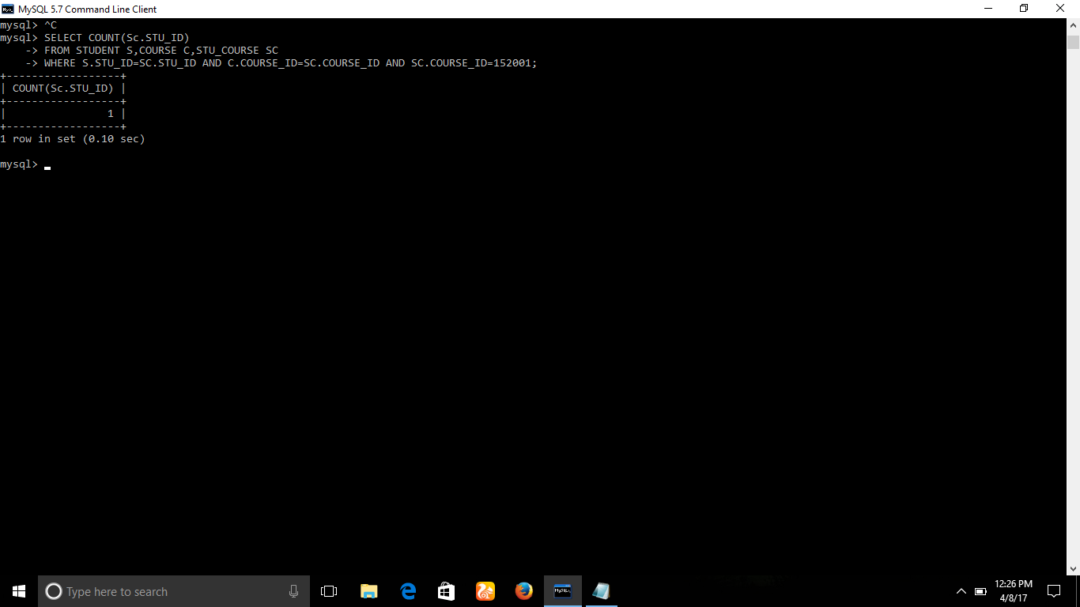

**5.DISPLAY THE ATTENDENCE REPORT CONSISTING STU_ID,STU_NAME,STATUS,DATE IN SECTION 1?**

**ANS:**

**mysql> select S.STU_ID,S.STU_NAME,A.STATUS,A.DATE**

**-> FROM ATTENDENCE A INNER JOIN STUDENT S ON A.STU_ID=S.STU_ID**

**-> WHERE A.SECTION_NO=1;**

**+-----------+----------+--------+------------+**

**| STU_ID | STU_NAME | STATUS | DATE |**

**+-----------+----------+--------+------------+**

**| 150030338 | JPR | P | 26-03-2017 |**

**| 150030336 | K.AVI | P | 27-03-2017 |**

**| 150030333 | KVP | P | 27-03-2017 |**

**| 150030338 | JPR | A | 28-03-2017 |**

**| 150030336 | K.AVI | A | 28-03-2017 |**

**| 150030333 | KVP | P | 28-03-2017 |**

**+-----------+----------+--------+------------+**

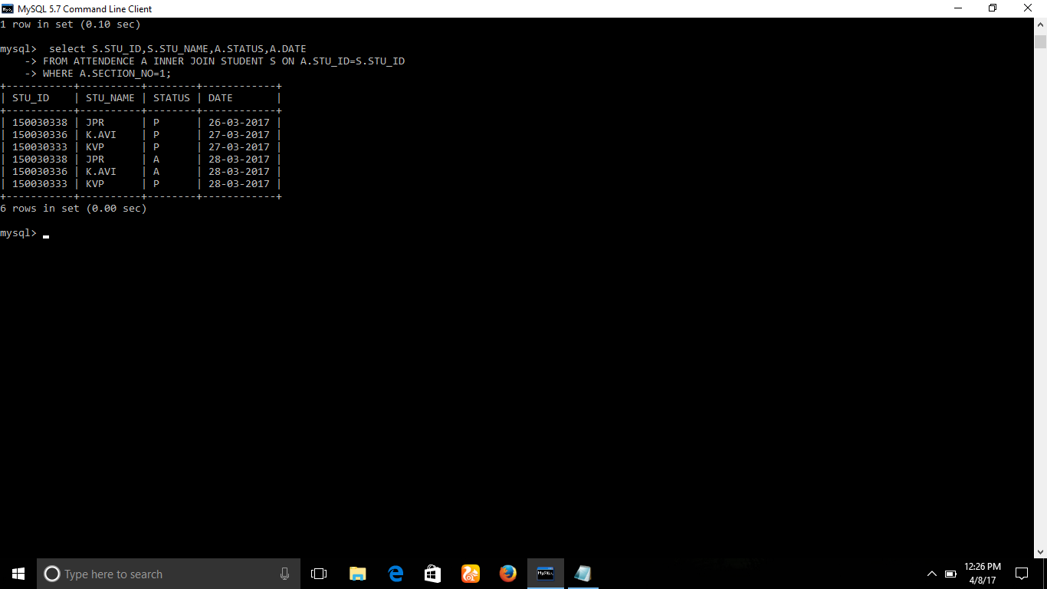

**6.DISPLAY THE ATTENDENCE REPORT OF STUDENTS IN INCREASING ORDER OF THEIR STU_ID IRRESPECTIVE OF THEIR SECTIONS?**

**ANS:**

**mysql> SELECT S.STU_ID,S.STU_NAME,A.STATUS,A.DATE**

**-> FROM STUDENT S,ATTENDENCE A**

**-> WHERE S.STU_ID=A.STU_ID;**

**+-----------+----------+--------+------------+**

**| STU_ID | STU_NAME | STATUS | DATE |**

**+-----------+----------+--------+------------+**

**| 150030333 | KVP | P | 27-03-2017 |**

**| 150030336 | K.AVI | P | 27-03-2017 |**

**| 150030337 | JVSR | P | 26-03-2017 |**

**| 150030338 | JPR | P | 26-03-2017 |**

**| 150030341 | JNC | P | 26-03-2017 |**

**+-----------+----------+--------+------------+**

**5 rows in set (0.00 sec)**

**7.SHOW THE NUMBER OF COURSES THE STU_ID 150030338 IS TAKING?**

**ANS:**

**mysql> SELECT COUNT(SC.COURSE_ID)**

**-> FROM STUDENT S,COURSE C,STU_COURSE SC**

**-> WHERE S.STU_ID=SC.STU_ID AND C.COURSE_ID=SC.COURSE_ID AND SC.STU_ID;**

**+---------------------+**

**| COUNT(SC.COURSE_ID) |**

**+---------------------+**

**| 5 |**

**+---------------------+**

**1 row in set (0.01 sec)**

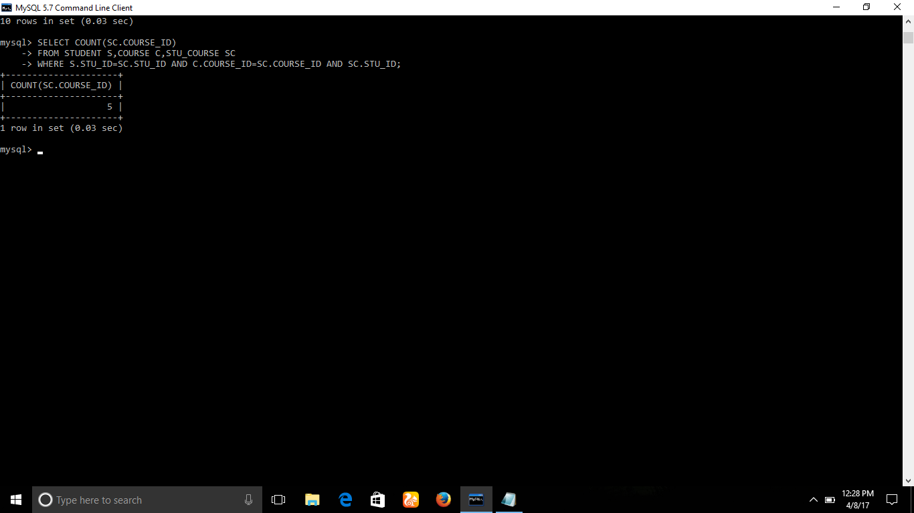

**8.DISPLAY THE ATTENDENCE OF THE STUDENTS BELONGS TO SLOTNO=1?**

**ANS:**

**mysql> SELECT A.STU_ID,A.STATUS,A.DATE**

**-> FROM ATTENDENCE A INNER JOIN SECTION S ON A.SECTION_NO=S.SEC_NO**

**-> WHERE S.SEC_SLOT_NO=1;**

**+-----------+--------+------------+**

**| STU_ID | STATUS | DATE |**

**+-----------+--------+------------+**

**| 150030338 | P | 26-03-2017 |**

**| 150030337 | P | 26-03-2017 |**

**| 150030336 | P | 27-03-2017 |**

**| 150030333 | P | 27-03-2017 |**

**| 150030338 | A | 28-03-2017 |**

**| 150030337 | A | 28-03-2017 |**

**| 150030336 | A | 28-03-2017 |**

**| 150030333 | P | 28-03-2017 |**

**+-----------+--------+------------+**

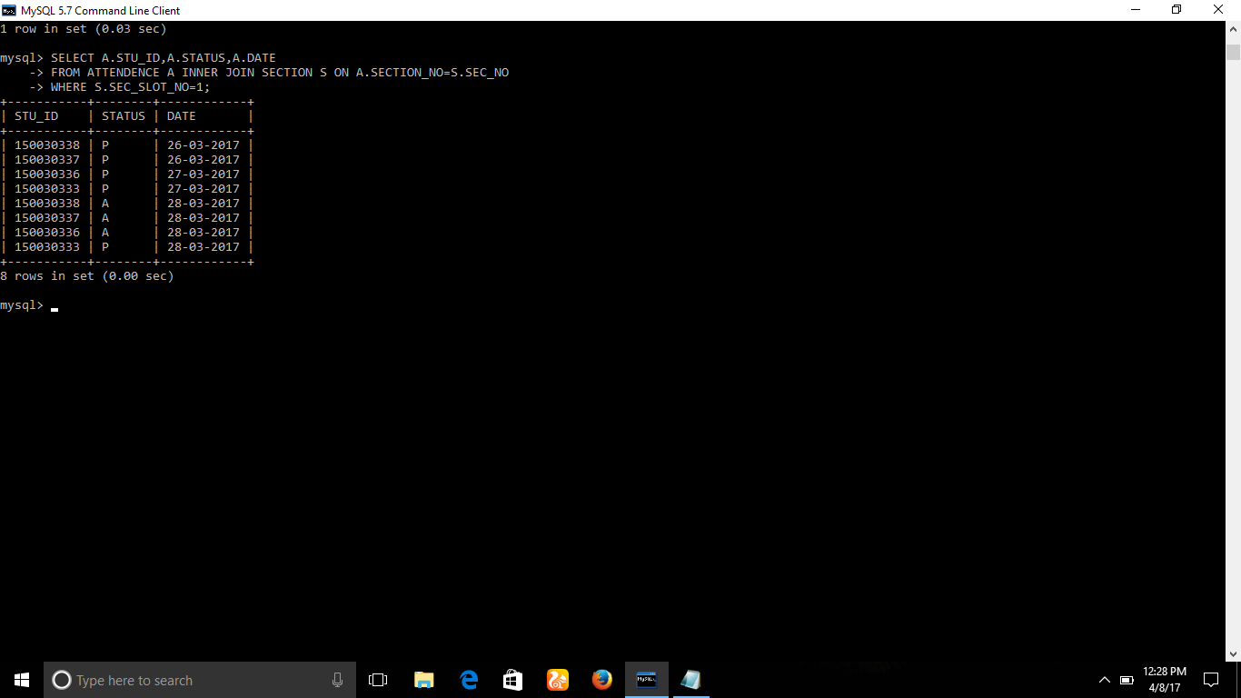

**9.DISPLAY THE STUDENT NAMES ASSOCIATED WITH FACULTY FROM SECTIONNO=1?**

**ANS:mysql> SELECT T.TEACHER_NAME,ST.STU_NAME**

**-> FROM SECTION S INNER JOIN TEACHER T ON T.SECTION_NO=S.SEC_NO INNER JOIN STUDENT ST ON ST.SECTION_NO = S.SEC_NO**

**-> WHERE S.SEC_NO=1;**

**+------------------+----------+**

**| TEACHER_NAME | STU_NAME |**

**+------------------+----------+**

**| K.THIRUPATHI RAO | KVP |**

**| K.THIRUPATHI RAO | K.AVI |**

**| K.THIRUPATHI RAO | JPR |**

**| R.SEHAR | KVP |**

**| R.SEHAR | K.AVI |**

**| R.SEHAR | JPR |**

**| V.HARI KIRAN | KVP |**

**| V.HARI KIRAN | K.AVI |**

**| V.HARI KIRAN | JPR |**

**| RAJYA LAXMI | KVP |**

**| RAJYA LAXMI | K.AVI |**

**| RAJYA LAXMI | JPR |**

**| PRASHANTH | KVP |**

**| PRASHANTH | K.AVI |**

**| PRASHANTH | JPR |**

**+------------------+----------+**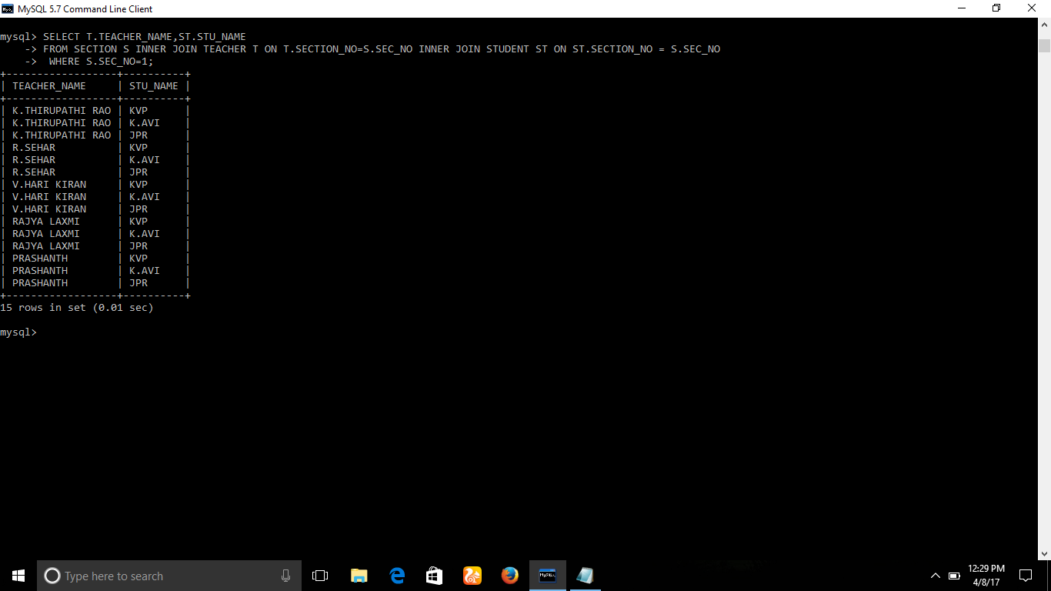

**10.WHERE CAN I FIND THE STUDENT WITH NAME='JPR'?**

**ANS:**

**mysql> SELECT ST.STU_ID,ST.STU_NAME,R.ROOM_NO,R.FLOOR_NO,R.BLOCK_NAME,ST.SECTION_NO**

**-> FROM SECTION S INNER JOIN STUDENT ST ON S.SEC_NO=ST.SECTION_NO INNER JOIN ROOM R ON S.ROOM_NO=R.ROOM_NO**

**-> WHERE ST.STU_NAME='JPR';**

**+-----------+----------+---------+----------+------------+------------+**

**| STU_ID | STU_NAME | ROOM_NO | FLOOR_NO | BLOCK_NAME | SECTION_NO |**

**+-----------+----------+---------+----------+------------+------------+**

**| 150030338 | JPR | 407 | 4 | C | 1 |**

**+-----------+----------+---------+----------+------------+------------+**

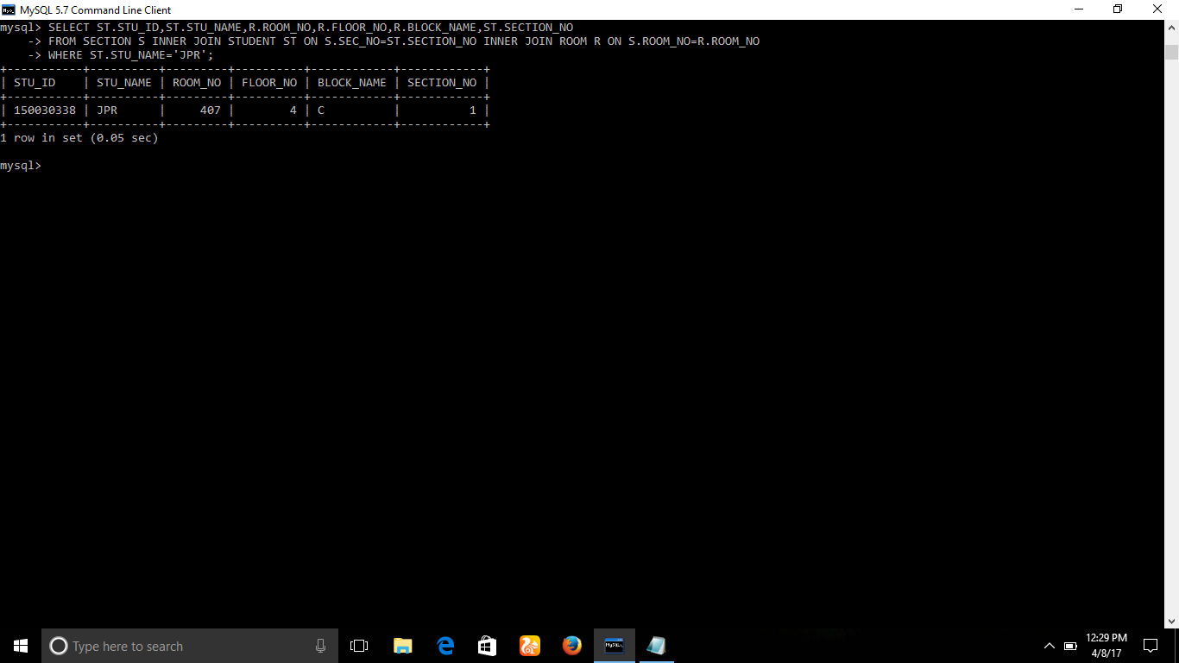

# feasibility

**Economically Feasibility:**

The system being developed is economic with respect to School or Collage’s point of view. It is cost effective in the sense that has eliminated the paper work

completely. The system is also time effective because the calculations are automated which are made at the end of the month or as per the user requirement. The result obtained contains minimum errors and are highly accurate as the data is required.

**Technical feasibility:**

The technical requirement for the system is economic and it does not use any other additional Hardware and software.

**Behavioural Feasibility:**

The system working is quite easy to use and learn due to its simple but attractive interface. User requires no special training for operating the system.

# ADVANTAGES OF PRESENT SYSTEM AND DISADVANTAGES OF PREVIOUS

**Working Of Present System**

In the present system all work is done on paper. The whole session attendance is stored in register and at the and of the session the reports are generated. We are not interested in generating report in the middle of the session or as per the requirement because it takes more time in calculation. At the end of session the students who don’t have 75% attendance get a notice.

**DISADVANTAGES OF PRESENT WORKING SYSTEM**

• **Not User Friendly:** The existing system is not user friendly because the retrieval of data is very slow and data is not maintained efficiently.

• **Difficulty in report generating:** We require more calculations to generate the report so it is generated at the end of the session. And the student not get a single chance to improve their attendance.

• **Manual control**: All calculations to generate report is done manually so there is greater chance of errors.

• **Lots of paperwork**: Existing system requires lot of paper work. Loss of even a single register/record led to difficult situation because all the papers are needed to generate the reports.

• **Time consuming**: Every work is done manually so we cannot generate report in the middle of the session or as per the requirement because it is very time consuming.

**CHAREACTERSTIC OF THE PROPOSED SYSTEM**

• **User Friendly:-** The proposed system is user friendly because the retrieval and storing of data is fast and data is maintained efficiently. Moreover the graphical user interface is provided in the proposed system, which provides user to deal with the system very easily.

• **Reports are easily generated:** reports can be easily generated in the proposed system so user can generate the report as per the requirement (monthly) or in the middle of the session. User can give the notice to the students so he/she become regular.

• **Very less paper work:** The proposed system requires very less paper work. All the data is feted into the computer immediately and reports can be generated through computers. Moreover work become very easy because there is no need to keep data on papers.

• **Computer operator control**: Computer operator control will be there so no chance of errors. Moreover storing and retrieving of information is easy. So work can be done speedily and in time.

# Conclusion

The Attendance Management System is developed using MYSQL which in turn fully meets the objectives of the system which it has been developed. The system has reached a steady state where all kind of errors have been eliminated. The system is operated at a high level of efficiency and all the teachers and user associated with the system understands its advantage. The system solves the problem. It was

intended to solve as requirement specification.